|  |  |
| --- | --- |
| **CL-1000**  **INFORMATION COMMUNICATION TECHNOLOGY LAB** | **LAB – 04**  **ADVANCED  MS EXCEL** |
| **NATIONAL UNIVERSITY OF COMPUTER AND EMERGING SCIENCES** | |

**ADVANCED MICROSOFT EXCEL 2007**

Microsoft Excel is a spreadsheet application that is used for basic data organization, statistical analysis, graphing data as well as many other uses. In this lab, we will take a look at what makes up an Excel spreadsheet and how to use it.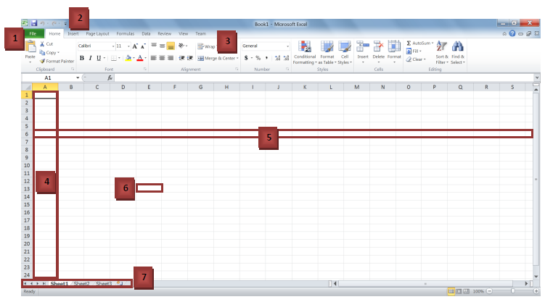

1. The File menu: This menu allows you to create, save, open and print spreadsheets.

2. Quick access toolbar: You can customize this toolbar to include all of the functions you use most, such as save and undo.

3. The ribbon: The ribbon contains all the office menus and toolbars. The ribbon is divided into tabs, each of which contains groups of controls.

4. Columns: Label 4 is one of the columns in the spreadsheet. Each column is labeled by the letter (or a string of letters) at the top of it.

5. Rows: Label 5 is one of the rows in the spreadsheet. Each row is labeled by the number to its left.

6. Cells: A cell is the intersection between a row and column. A cell is where most of the excel data is entered. A cell’s address is the row and column it is in, for instance, the boxed cell (label 6) is in column E and row 13; hence, its address is E13.

7. The worksheet toolbar: An Excel file is called a workbook. It consists of a number of spreadsheets (worksheets). This toolbar allows you to move between the different sheets in a workbook. It also allows you to create new worksheets, delete existing sheets, and rename sheets.

**Entering Data in Workbook:**

Data in a workbook can be either text or numbers. Data can also be categorized into labels, values, or text.

**Values -** Values are the raw numeric data that are entered in a spreadsheet for calculation. Users are not required to enter any comma or currency units, as formatting of the data is performed by using the number formats provided by Excel. However, users have to take care of the decimal point in the data.

After a user enters the data and presses the **ENTER** key, Excel automatically aligns the value to the right of the cell and moves the cell pointer down by one cell.

**Note:** To enter a numeric value with 0 in the beginning, enter a single quote mark (‘) before the numeric value to retain the zero. For example, to enter 001, type ‘001 in the active cell.

**Text -** Text is the alphabetical data entered in the spreadsheet and is used to serve a descriptive purpose. Usually, such type of data is used for entering names of people, months of the year, days of the week, and so on. When users enter text data, Excel automatically aligns it to the left of the cell.

**Labels -** Labels are pure text or alphanumeric data that support the information present in the table or paragraph. They are entered as row and/or column headings to describe what that particular range of cells represent. When users type the text data, Excel automatically aligns it to the left of the cell. After entering the label, users can format the data according to their requirements.

**Formulas -** Excel enables user to enter formulas that uses the value present in the cell to calculate a result. When a formula is entered in a cell, the formula’s result is displayed as the cell. Changing the values used by the formula enables the formula to recalculate and show the result.

**AutoComplete -** Excel provides the AutoComplete feature to fill in certain data automatically in the spreadsheet. It keeps a list of all the pure text or alphanumeric data that has been entered earlier in the spreadsheet. Depending on the similarities of labels in a particular column, users may have to type out many letters until it displays the label name. When the AutoComplete feature of Excel displays the required entry in the cell, press ENTER.

**Writing Formula in Excel:**

To create simple mathematical formulas, perform the following steps:

1. Open **Microsoft Excel**.
2. Click cell **A1**.
3. Type the value $324.
4. Click cell **A2**.
5. Type the value $234.
6. Click cell **A3** to contain the formula.
7. Type = to start the formula.
8. Type the first reference cell, A1.
9. Type the Math operator, +.
10. Type the second reference cell, A2.

Figure 10.1 displays the worksheet with the numeric values and formula.

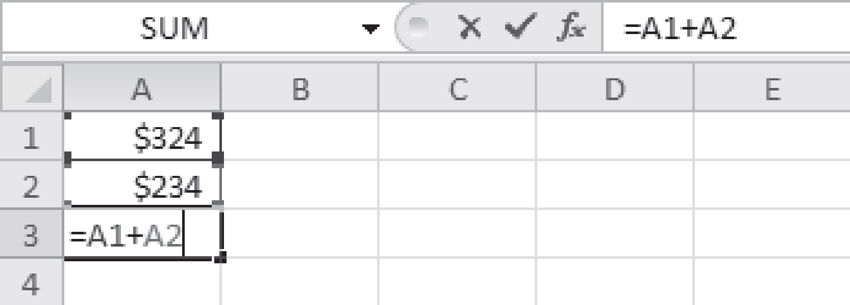

**Figure 10.1: Addition of Numbers**

1. Press **ENTER** after the formula has been entered. This will add the data present in cells A1 and A2 and display the result in cell A3.

**Splitting & Freezing panes:**

Splitting or freezing panes allow you to hold sections of a worksheet in place so they are visible at all times whilst scrolling through the worksheet. This is especially useful for large worksheets because you can hold the column and row headings in place whilst you scroll through your data.

**Splitting panes on a worksheet:**

Splitting panes allows you to see multiple areas of a worksheet at once. So you can make changes to the data in cell D500 whilst viewing the data in cell D5.

1. Select the cell where you want to split the worksheet

The worksheet will be split above and to the left of the active cell creating four panes.

1. Click the **View** tab on the Ribbon
2. Click the **Split** button in the Window group

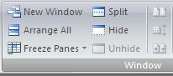

The worksheet is split into sections that can be navigated individually without moving the other sections.

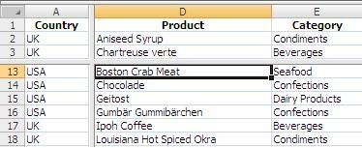

Click and drag the panes to adjust the location of the split.

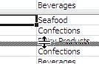

Click the **Split** button in the Window group on the Ribbon again to remove the split.

Worksheets can also be split using the split buttons at the top and to the right of the worksheets scroll bars. To split the worksheet, drag the relevant split button onto the area of the worksheet where you wish to create the split.

|  |
| --- |
| Split buttons |

Freezing panes on a worksheet:

Freezing panes is similar to splitting panes except that the panes are immobilized. Freeze panes is used to hold headers in place so that they can always been seen when scrolling through the worksheet.

1. Click the **View** tab on the Ribbon
2. Click the **Freeze Panes** button in the Window group

A list appears with three options

* **Freeze Panes:** Freezes the worksheet above and to the left of the active cell.

Ensure that you select the required cell before clicking this option. Unlike split panes, frozen panes cannot be moved. You need to unfreeze the panes and then freeze again.

* **Freeze Top Row:** Freezes the top row, keeping it visible whilst you scroll through the rest of the worksheet.
* **Freeze First Column:** Freezes the first column, keeping it visible whilst you scroll through the rest of the worksheet

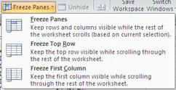

1. Select the desired option from the list

The relevant panes are frozen and the worksheet can be navigated as required

To unfreeze panes, click the **Freeze Panes** button in the Window group and select **Unfreeze Panes.**

**Conditional Functions:**

One very useful set of built-in functions in Excel is conditional functions. As the name implies, these perform certain operations based when a specified condition is satisfied. This is best illustrated through an example.

For this, we use the function COUNTIF. The form of this function is COUNTIF(Range, Criteria). The range is the data values you would like the count to be performed on, and the criteria are the conditions that need to be satisfied for a cell to be included in the count.

Let us count the number of employees in the IT department. Type **=countif(** and then select the range of cells we would like to count.

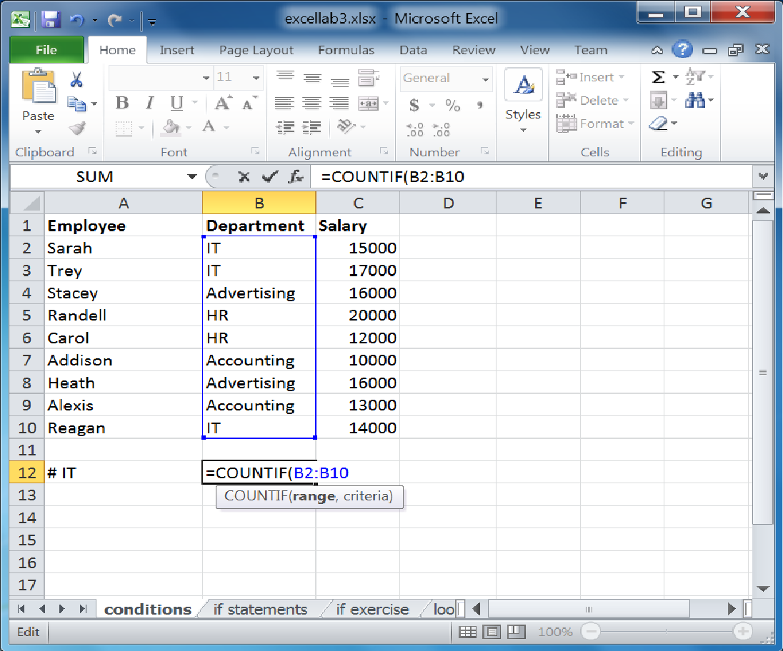

Now we need to enter the criteria.

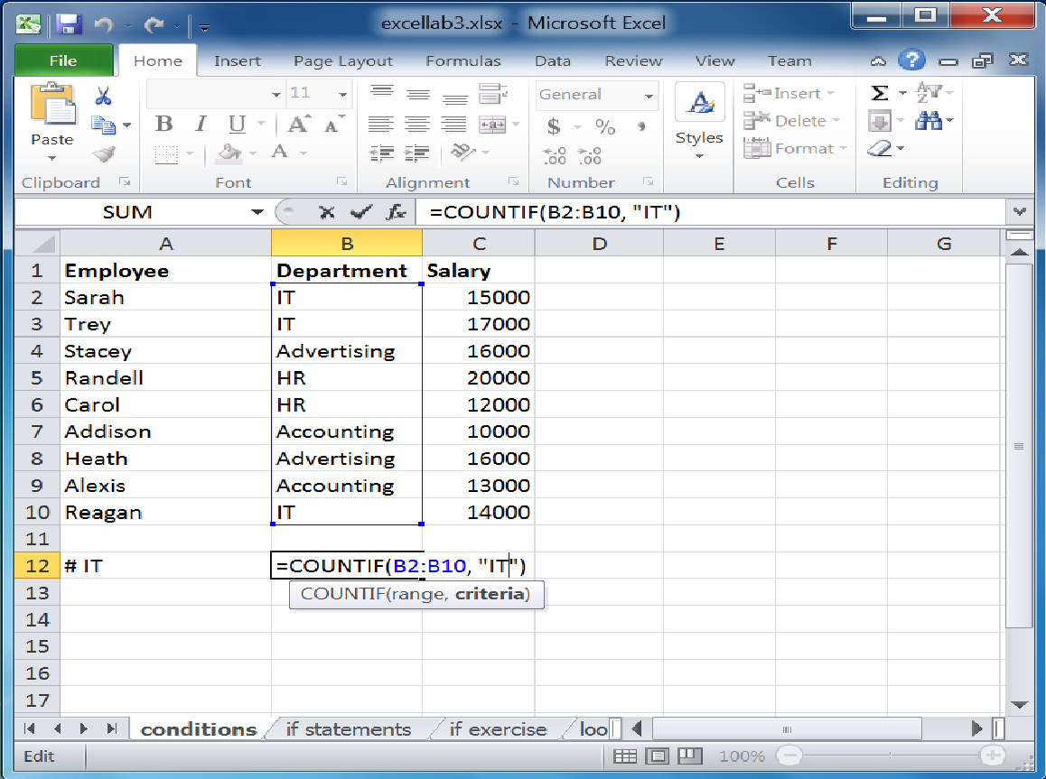

It’ll return “3” as answer since there are 3 employees in IT department.

SUMIF works in almost the same way as COUNTIF, except it returns the sum instead of the count. For instance, let us calculate the sum of all salaries greater than 15000.

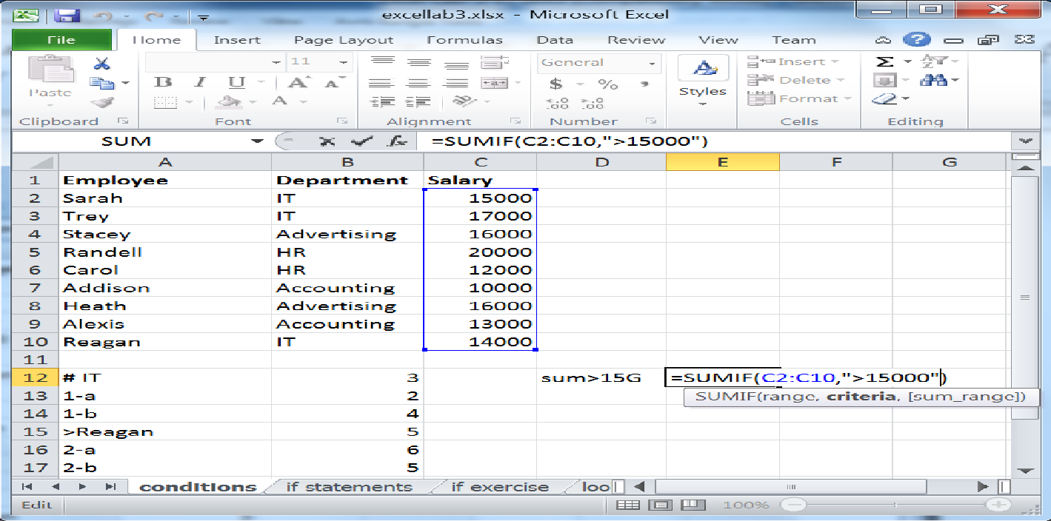

**IF function:**

IF functions or statements allow you to ask the question “is this true or false?” It then allows you to implement different actions based on the outcome. That is, it allows you to compute two different outcomes based on whether a certain criterion (logical test) is true or false. The format of an IF statement is as follows:

=IF(*logical test*, *value if true*, *value if false*).

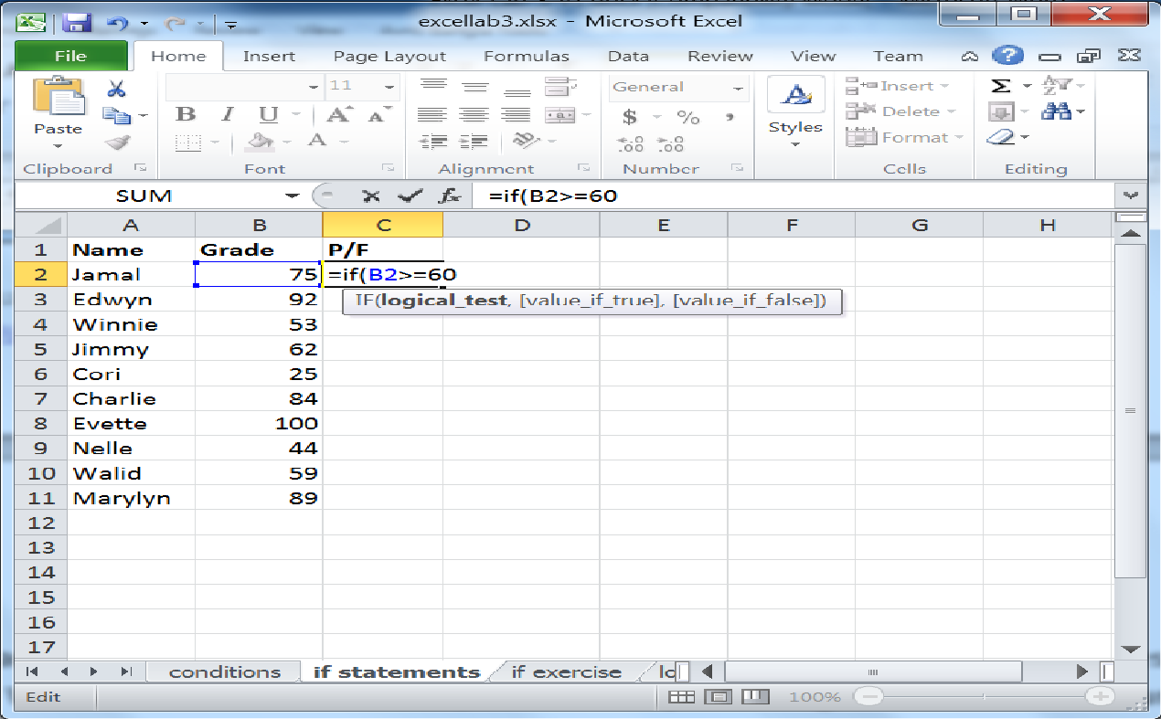

**Statistical Functions:**

To find the statistics of grouped quantities, MS-Excel provides us the Statistical Functions. You can find it in Formulas tab (in “Statistical” under More Functions). Some of the Statistical Functions are explained below:

|  |  |
| --- | --- |
| **Functions** | **What it Does** |
| **AVERAGE** | Returns the average of its arguments |
| **COUNT** | Counts how many numbers are in the list of arguments |
| **AVERAGEA** | Returns the average of its arguments, including numbers, text, and logical values |
| **COUNTA** | Counts how many values are in the list of arguments) |
| **RANK** | Returns the rank of a number in a list of numbers |
| **LARGE** | Returns the k-th largest value in a data set |
| **SMALL** | Returns the k-th smallest value in a data set |
| **MIN** | Returns the minimum value in a data set |
| **MAX** | Returns the maximum value in a data set |

**Conditional formatting**

Conditional formatting allows you to make data trends stand out visually.

First, start by selecting your data range:

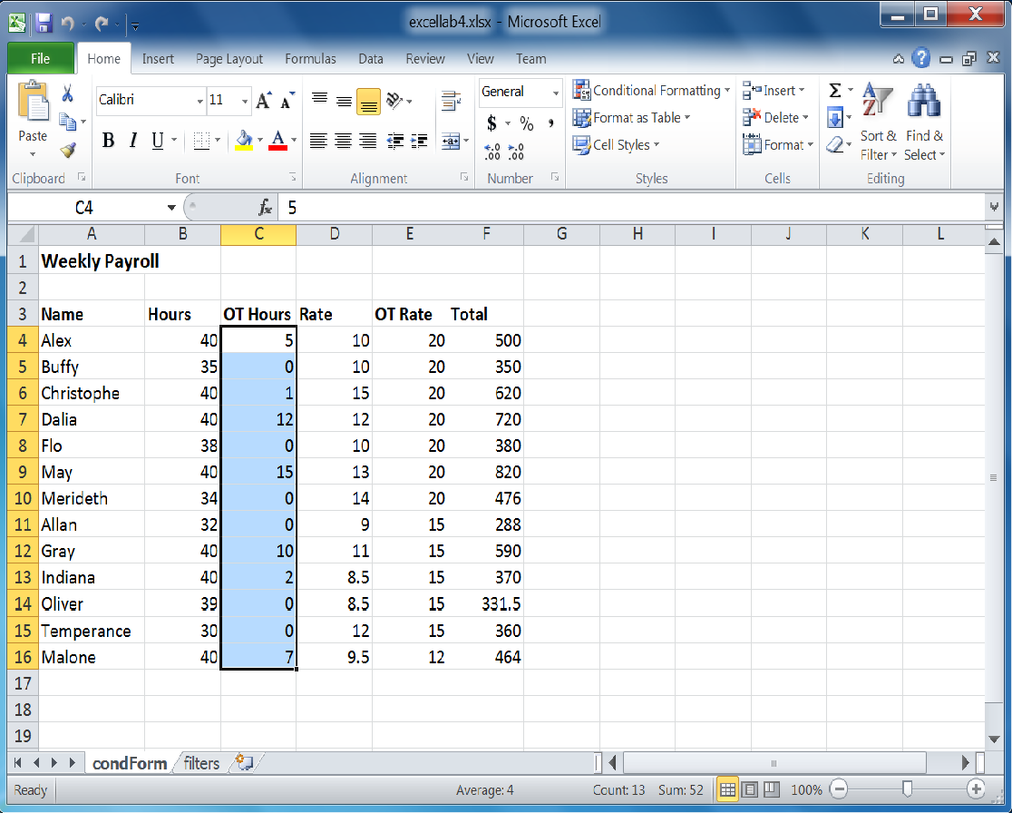

In the Home tab, click on Conditional Formatting in the Styles group. Move the mouse pointer over Highlight Cells Rules, and then click Greater Than.

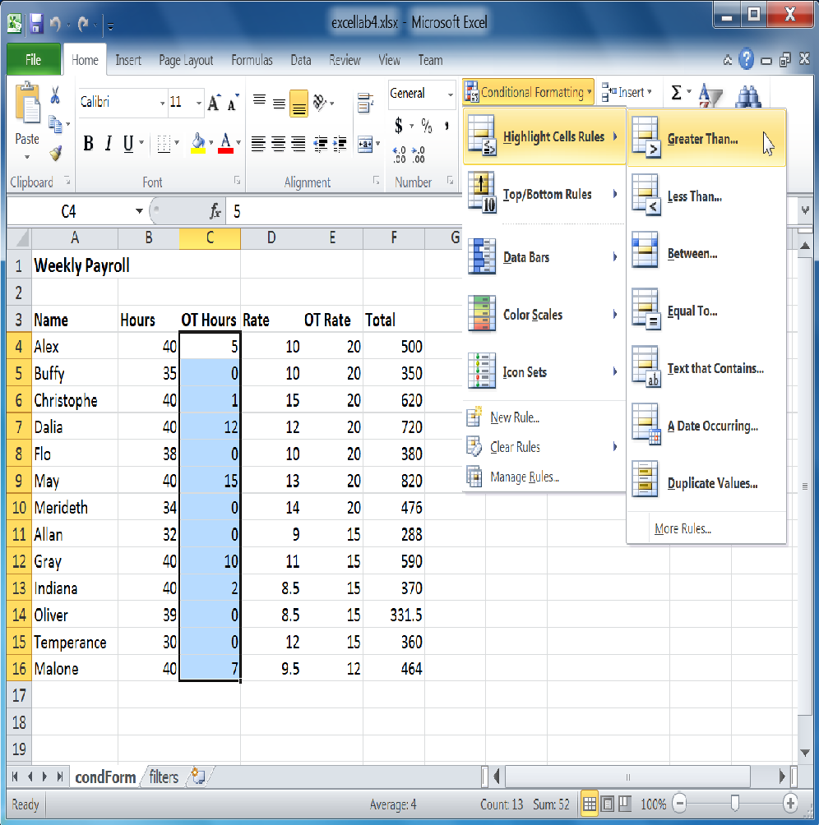

Now enter 10 in the textbox present in the dialog box and click OK.

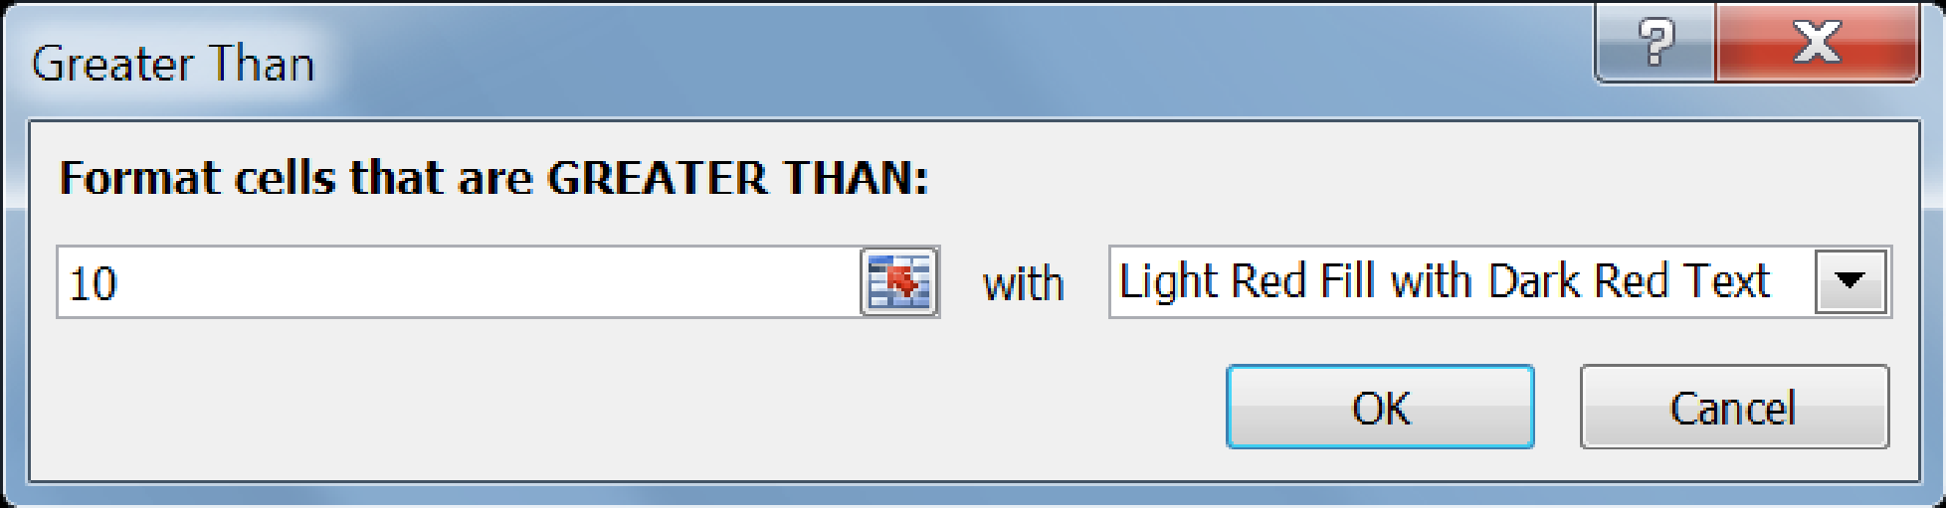

OT Hours that are greater than 10 are now highlighted.

**SORT AND FILTER:**

**Sorting lists**

Sorting a list or sorting an entire table are both functions that will most likely come up whenever you are doing data analysis. You can easily sort data in alphabetic, numeric, or even chronological order.

Let us try sorting our table by the ascending alphabetic order of the names of the employees.

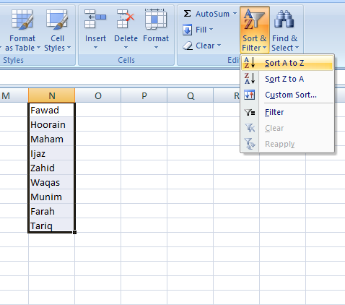

Select the range of names in the table. Then in the Home tab, under the Editing group, select Sort A to Z.

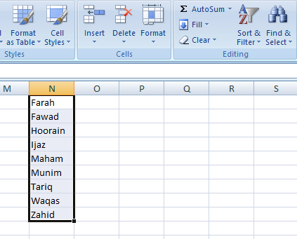

And here you have your sorted list of employee’s names.

**FILTERING A LIST**

Filtering in Excel allows you to show only the rows of data you are concerned with, and hide all other data temporarily.

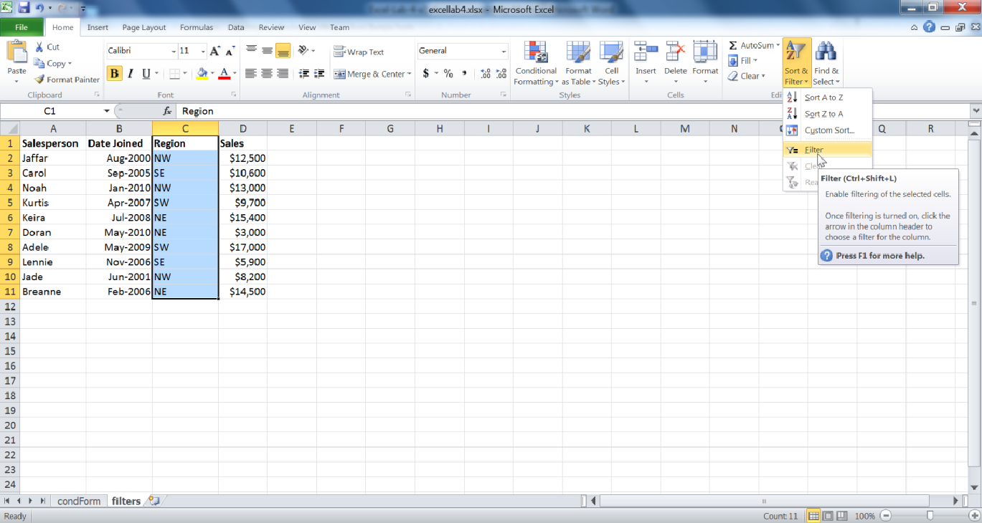

One obvious use for filters here is to view the sales information of only a few regions of interest. Let us see how this can be done.

Start by selecting the Region column. Under the Home tab and in the Editing Group, select the Sort and Filter button. Select Filter from the menu.

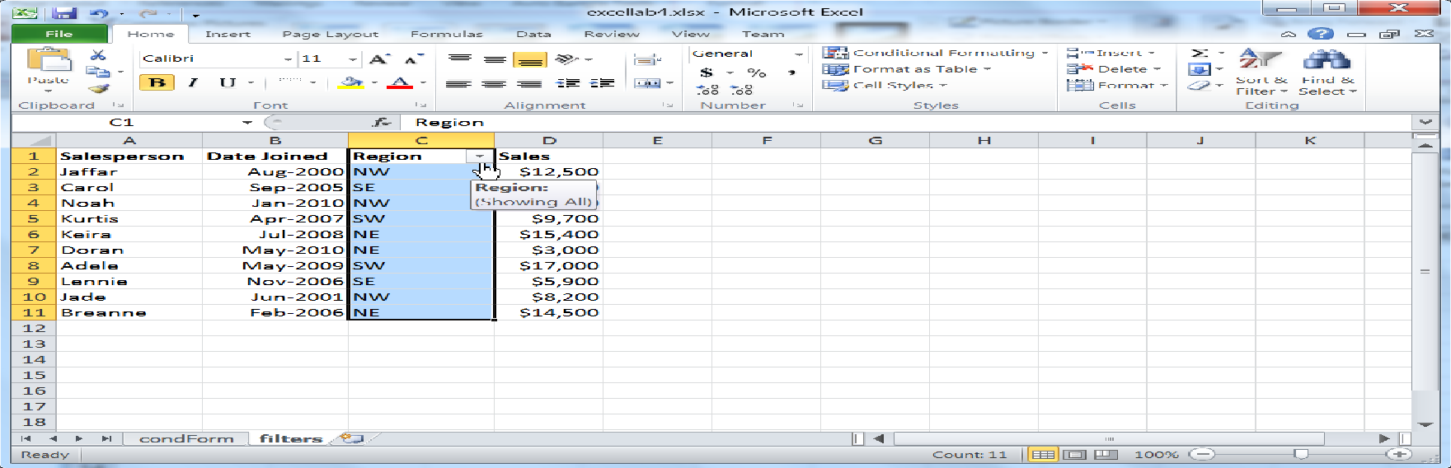

Notice that there is now an arrow next to the Region header. This arrow means that a filter can be applied to this column, but no filters are currently being used.

Click the arrow next to the Region header. Let us only show the data for sales in the East region. One way to do this is to deselect NW and SW as shown below.

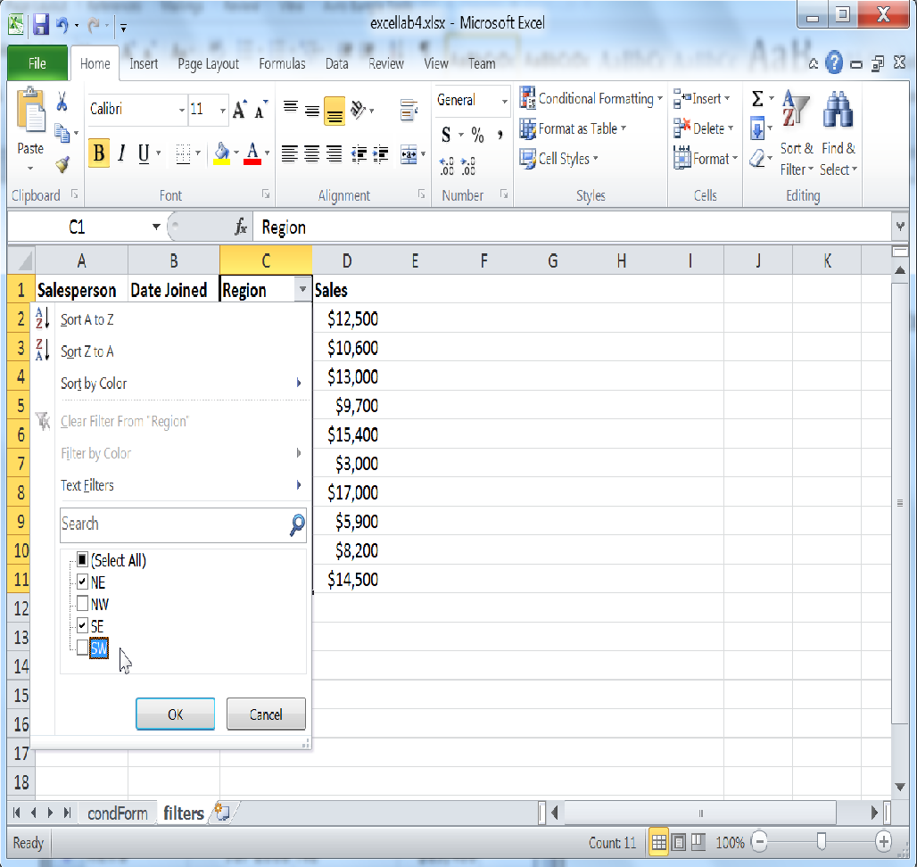

Now, only the rows showing information from either the NE or SE are shown. Notice the button next to the region header has changed to a filter icon indicating that a filter has been applied.

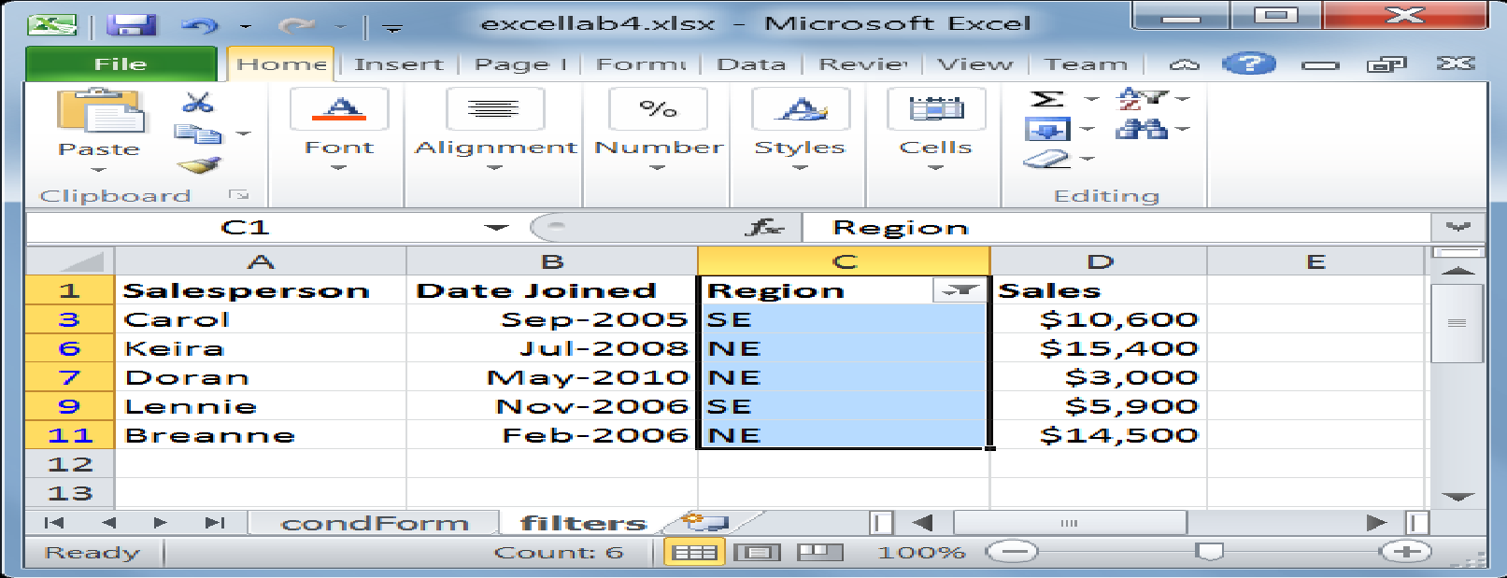

You can perform the same task by creating a Custom AutoFilter as well. Just follow the steps:

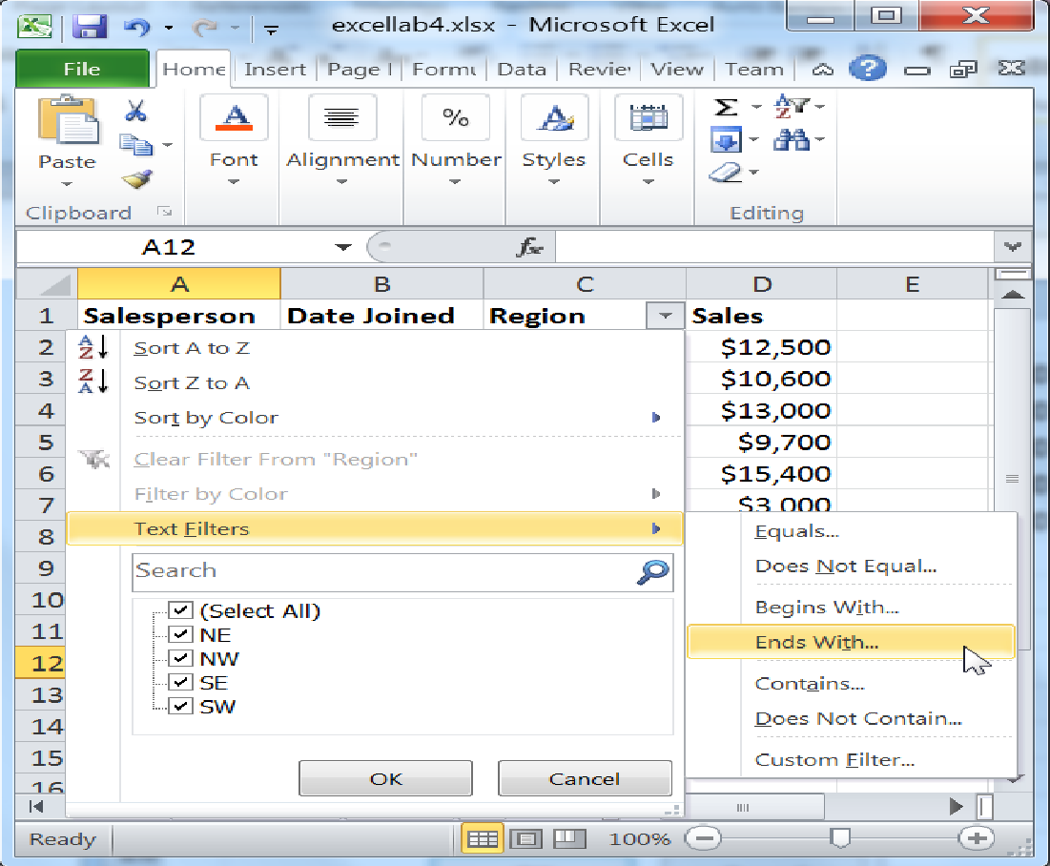

After clicking on “Ends With…”, a dialog box will appear for creating a custom AutoFilter:

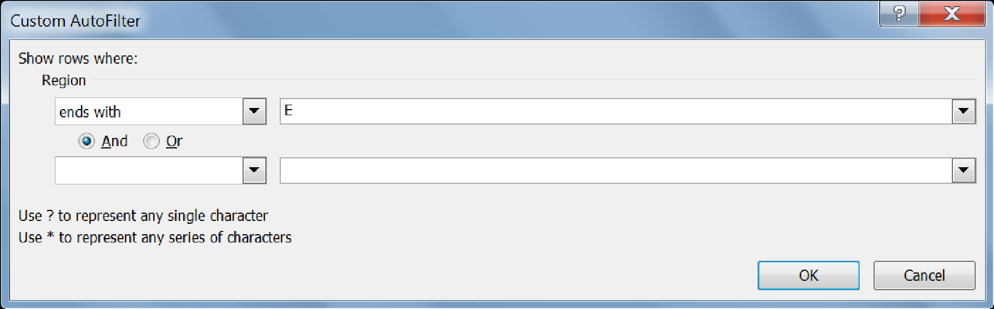

Click OK, and you have created your Custom AutoFilter successfully.

**CHARTS AND PIVOT TABLES:**

A picture is worth a thousand words! Often it’s much easier to understand data when it’s presented graphically, and Excel provides the perfect tools to do this.

Turning data into charts can help visualize the information at hand. To convey the appropriate message from your data, you need to select an appropriate type of chart for your data.

Let us start out with creating a simple chart using the chart wizard.

On the ribbon, click the Insert tab. There you will notice the Charts group, showing all the different types of charts that can be created out of the data. Select the 1st option in 2D bars (the clustered bar chart).

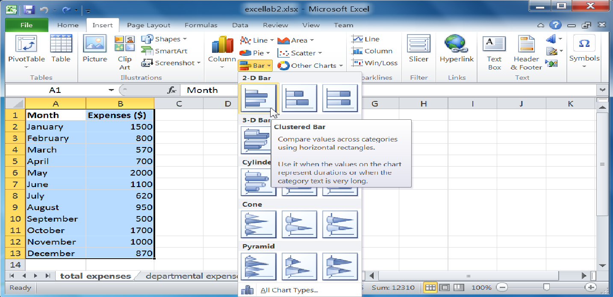

And this is what you will get:

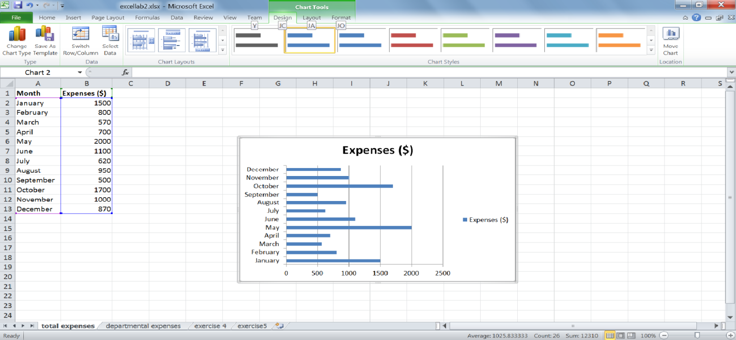

You can add Axis-Title in the chart as well:

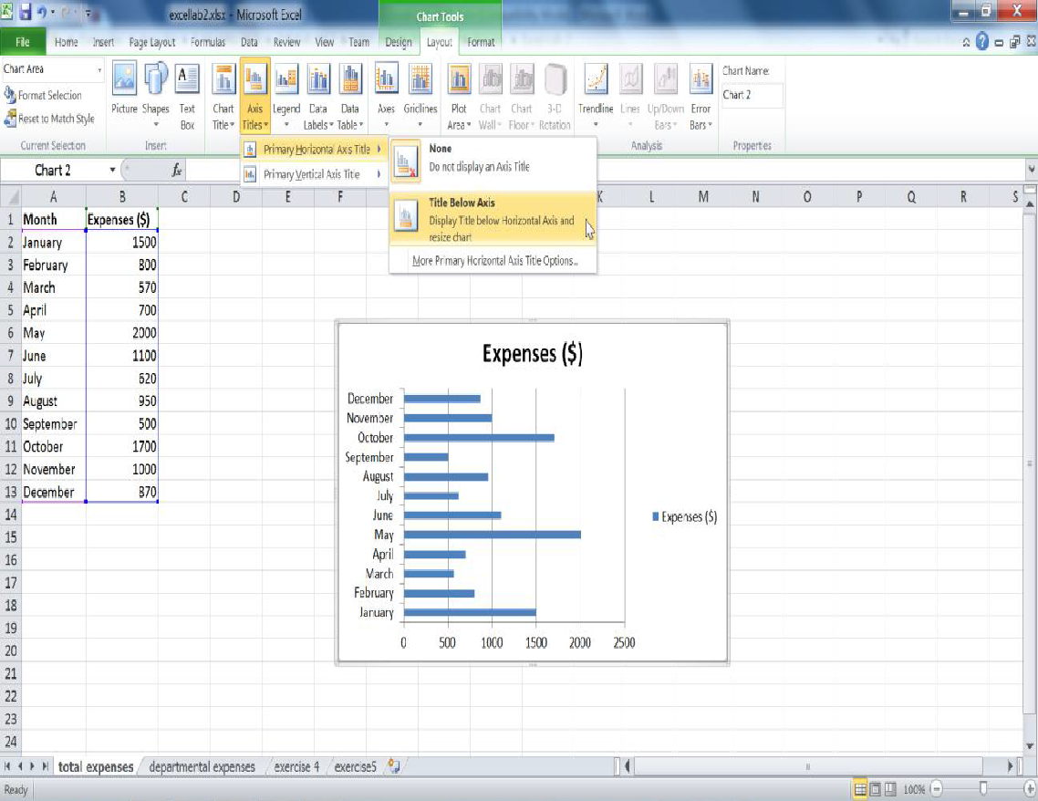

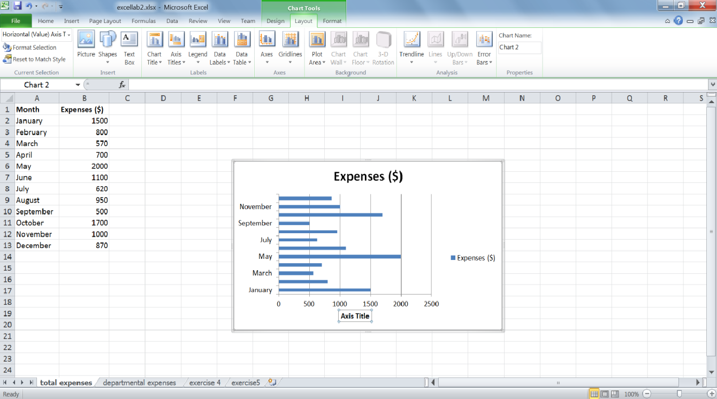

**PIVOT TABLES:**

Pivot tables are used to easily create meaning out of large amounts of data. Let us take an example. Open the departmental expenses sheet. Select the entire table and then go to the Insert tab on the ribbon. Click the PivotTable button.

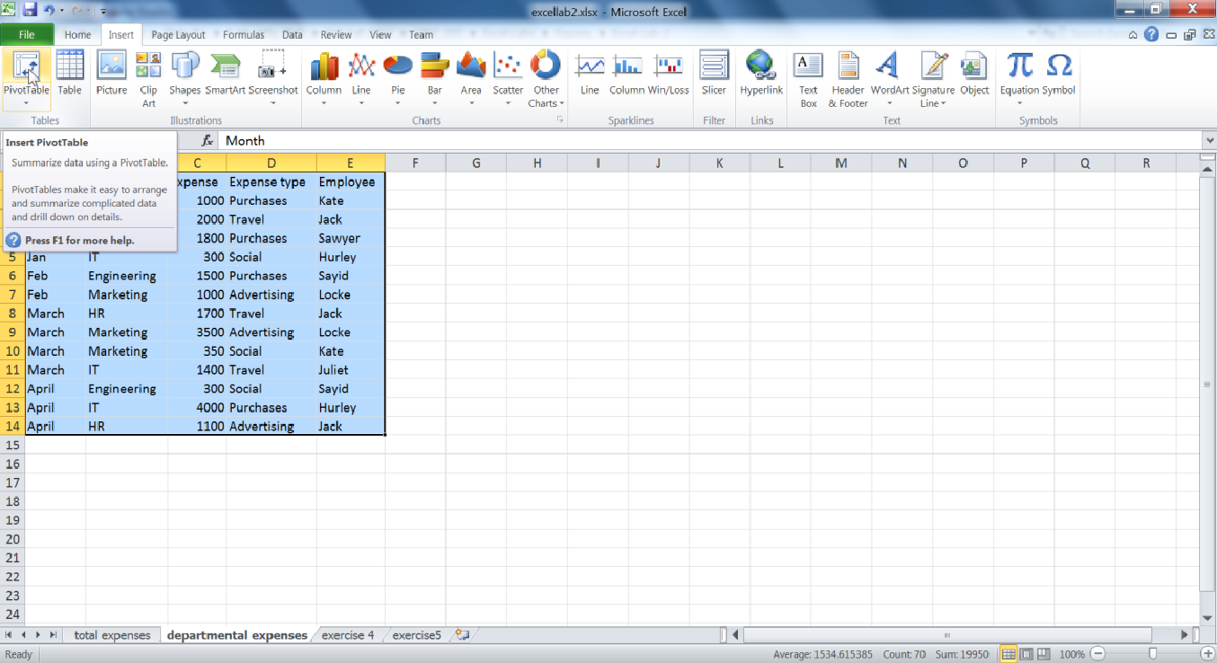

The dialog box that pops up allows you to modify the range of data to be used for the pivot table, and to choose where the pivot table needs to be placed.

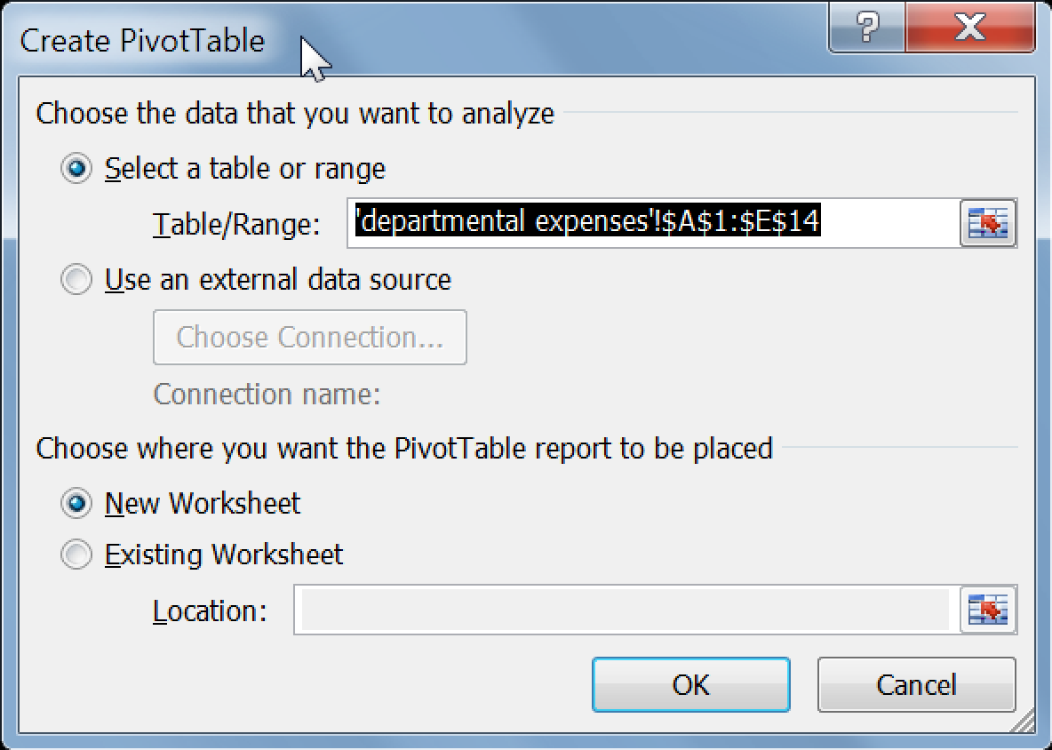

By clicking OK, you will get an empty Pivot Table which will look like this:

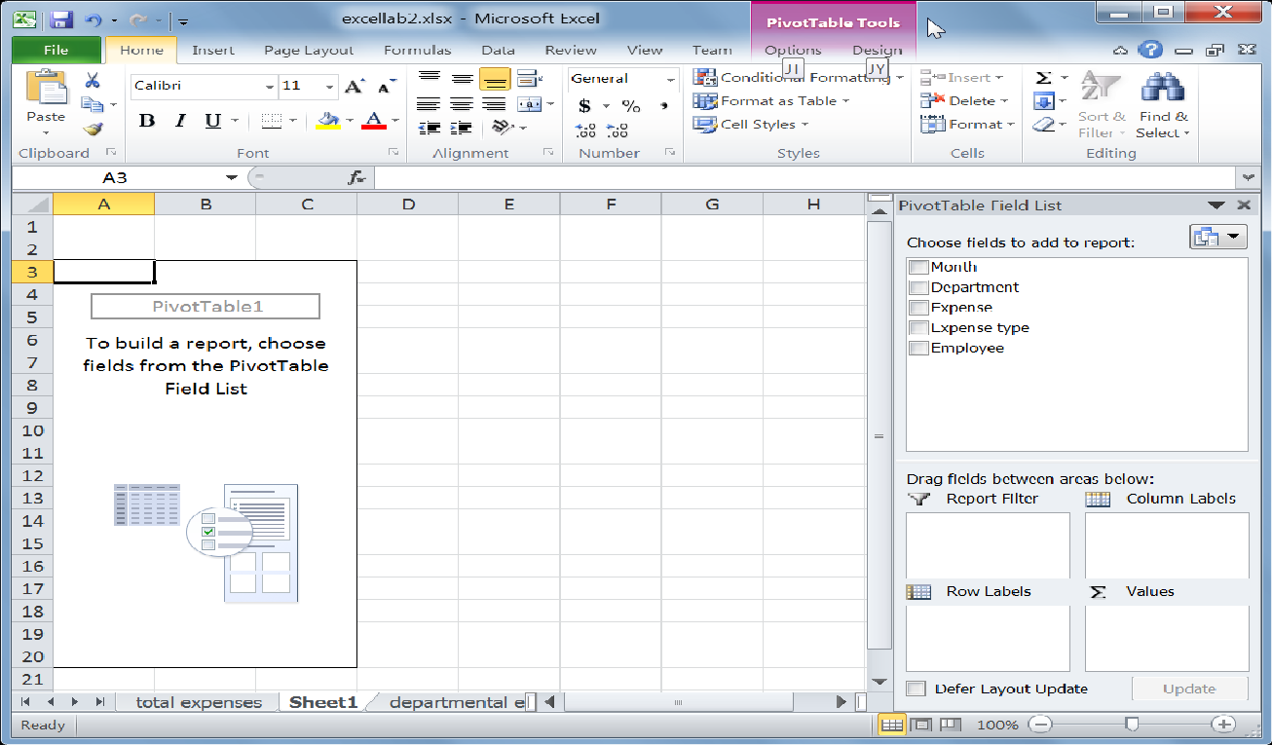

Let us first take a look at what the different field areas are used for. Their usage will become clear shortly.

* *Values:* this is used to display summary calculations in the pivot table.
* *Row labels:* these labels are used to display fields as rows on the side of the pivot table. The table is broken down by the first row label; each subsequent label appears as subcategory of the previous label.
* *Column labels:* these labels are used to display fields as columns on the top of the pivot table. Column labels are nested in a similar way to row labels.
* *Report filter:* this is used to filter the whole report (the pivot table).

The pivot table menu to the right allows you to select the fields you want to add to the table. Select all of the fields by clicking their respective checkboxes.

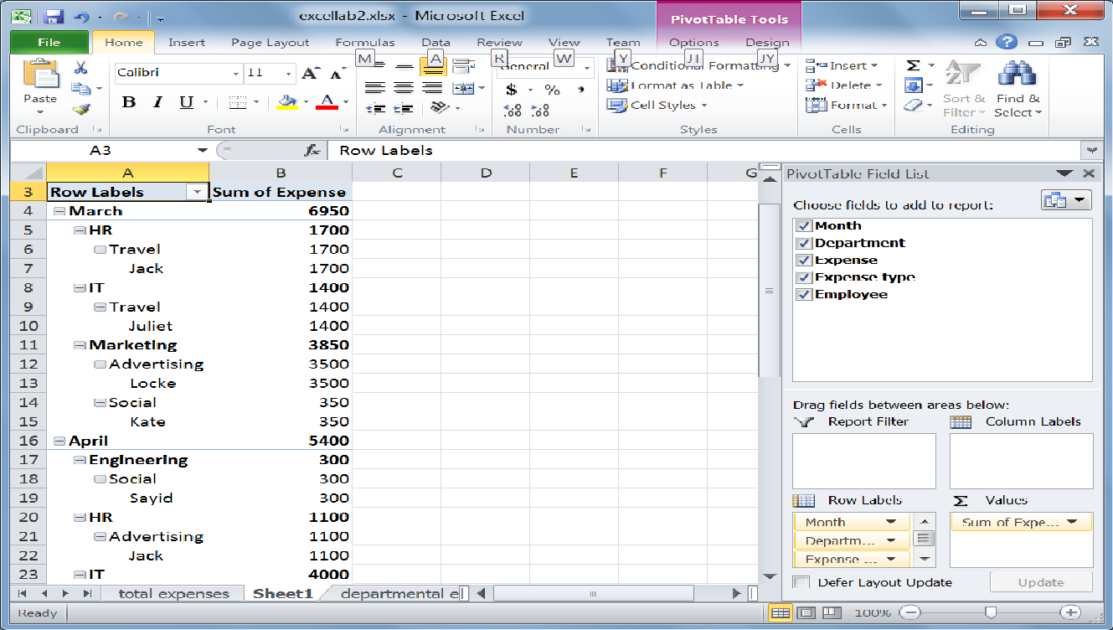

Right now things aren’t looking so sensible as far as the visual of the table is concerned. So, we have to tweak it a little bit as per our requirements.

Notice that all the fields have come under Row Labels, except for Expense, which is under Values.

Drag the Expense Type field to Report Filter. Drag the Department field to the Column Labels.

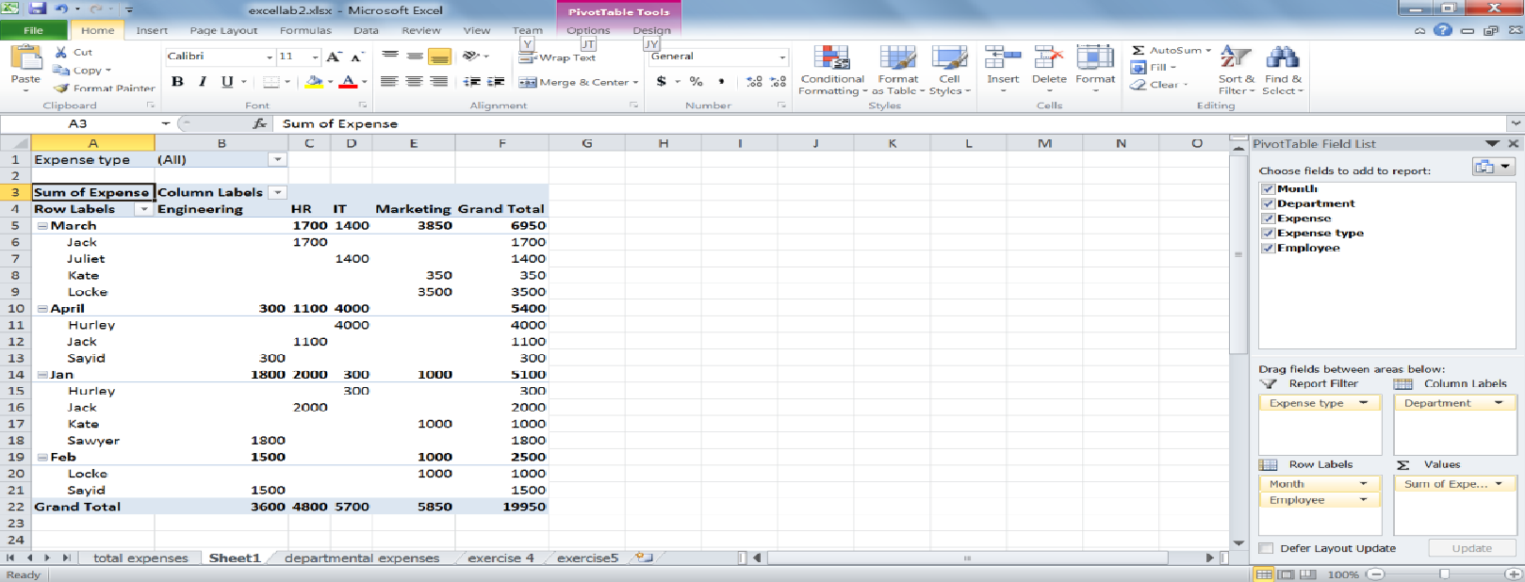

Now assume that we only want the information for Travel and Social expenses. Click on the drop-down field next to Expense type, and then check the Select Multiple Items checkbox. After that, deselect the Expense types we do not need and click OK. Now, the pivot table shows the information for only the required expense types.

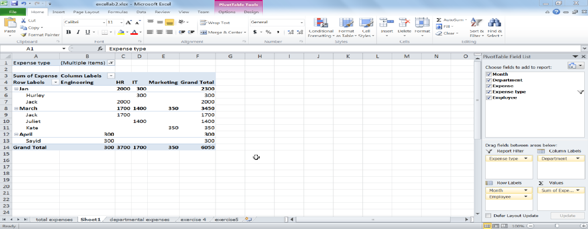

**File Protection:**

You can make your MS-Excel worksheet password protected by following these steps:

* 1. Go to REVIEW tab, and click PROTECT WORKSHEET option.
  2. A dialog box will appear in which you can decide what actions are allowed for user and what actions are prohibited.
  3. After check marking the desired options, give a password to unprotect worksheet and click OK.

